OMNIRETAIL CUSTOMER ANALYTICS
Project Documentation

Satisfaction & Loyalty Analysis – Power BI Dashboard

INTRODUCTION
OmniRetail is a U.S. retail chain selling electronics and smart home products through both online and physical stores. To improve customer satisfaction and retention, the company collected customer feedback throughout 2024, combining satisfaction scores, purchasing behavior, demographics, support history, and location data. This analysis synthesizes that data to surface which factors most influence satisfaction and loyalty, which customer segments and regions are strongest or weakest, and where the business should focus its retention efforts.

Problem Statement
OmniRetail lacks a clear, data-driven picture of what drives high versus low satisfaction, whether contacting customer support helps or hurts the relationship, which locations are under-performing, and whether different demographic segments respond to different satisfaction drivers. This report uses the 2024 feedback dataset to answer those questions and recommend where to act first.

Key Questions for Analysis
- What are the main factors contributing to high vs. low satisfaction scores?
- Are certain customer segments (by age, gender, group) more loyal than others?
- Which locations (cities or states) report consistently high or low satisfaction scores?
- Does contacting customer support negatively impact satisfaction?
- How do factors like "Price" or "Product Variety" influence customer loyalty?
- Do repeat purchasers report higher satisfaction compared to one-time buyers?
- What is the relationship between loyalty level and satisfaction score?
- Do specific demographic groups favor certain satisfaction factors (e.g., Packaging vs. Price)?

Objectives
- Identify the satisfaction factors most responsible for high and low scores.
- Determine whether loyalty varies meaningfully by age, gender, or customer group.
- Flag the states and cities with consistently strong or weak satisfaction.
- Assess whether contacting support, and being a repeat buyer, relate to loyalty and satisfaction.
- Translate these findings into targeted retention actions by segment and region.

DATA DESCRIPTION
Data Source
The data used for this analysis is the customer satisfaction dataset supplied for the OmniRetail analytics challenge, covering feedback collected across 2024.

Data Overview
The dataset covers 120 customers across 6 states, and includes the following fields:
Column | Description
Customer_ID | Unique customer identifier (internal use only)
Group | Customer classification — A: high-frequency shoppers, B: moderate-frequency (the version analyzed here contains Groups A and B)
Satisfaction_Score | Customer's rating of their experience (1 = very poor, 10 = excellent)
Age / Age_Group | Age in years, bucketed into 25-34, 35-44, 45-54, 55-64
Gender | Female / Male
Location | City and State, with latitude and longitude for mapping
Buyer_Type | Repeat Buyer or One-Time Buyer
Support_Contacted | Whether the customer contacted support (Yes/No)
Loyalty_Level | OmniRetail's internal rating: Low / Medium / High loyalty
Satisfaction_Factor | The main reason behind the satisfaction score (e.g., Price, Product Variety, Packaging)
Satisfaction_Level | Categorical band of the score (Very Poor, Poor, Good, Very Good, Excellent)

METHODOLOGY
Data Cleaning
The dataset was reviewed for missing values, duplicate customer records, and inconsistent category labels (e.g., state names, Yes/No fields) before being loaded into Power BI. At 120 rows, the data was checked in full rather than sampled.
Data Transformation
Two fields were added as calculated columns: Age_Group (bucketing raw Age into four bands) and Satisfaction_Level (bucketing Satisfaction_Score into five bands). Representative DAX for each is shown below;
Age_Group — buckets raw age into four bands:
Age_Group =
SWITCH(TRUE(),
[age] < 25, "Under 25",
[age] < 35, "25-34",
[age] < 45, "35-44",
[age] < 55, "45-54",
[age] < 65, "55-64",
"65+"
)
Buyer_Type :
Buyer_Type =
IF(Customer_Dataset[purchase_history] = "Yes", "Repeat Buyer", "One-Time Buyer")

Measures
Total Customers:
Total customers = COUNT(Customer_Dataset[Customer_ID])

Contacted Support Percentage:
%_Who_Contacted_Support =
DIVIDE(
CALCULATE(COUNTROWS(Customer_Dataset), Customer_Dataset[support_contacted] = "Yes"),
COUNTROWS(Customer_Dataset)
)

Average Satisfaction Score:
Avg_satisfaction_score = AVERAGE(Customer_Dataset[Satisfaction_Score])

Repeat Buyers Percentage:
%_Repeat_Buyers =
DIVIDE(
CALCULATE(COUNTROWS(Customer_Dataset), Customer_Dataset[purchase_history] = "Yes"),
COUNTROWS(Customer_Dataset)
)

Most Loyal Age Group:
Most_Loyal_Age_Group =
CONCATENATEX(
TOPN(
1,
SUMMARIZE(
Customer_Dataset,
Customer_Dataset[Age_Group],
"HighCount", CALCULATE(COUNTROWS(Customer_Dataset), Customer_Dataset[loyalty_level] = "High")
),
[HighCount], DESC, -- primary sort: highest count
Customer_Dataset[Age_Group], ASC -- tiebreaker: alphabetically first
),
Customer_Dataset[Age_Group],
", "
)

KEY FINDINGS
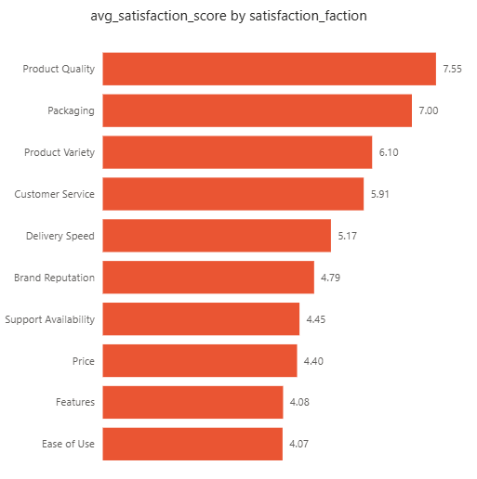
(1) What are the main factors contributing to high vs. low satisfaction scores?
Avg. satisfaction score by Satisfaction_Factor
- Product Quality (7.55) and Packaging (7.00) have the highest average satisfaction scores; Ease of Use (4.07), Features (4.08) and Price (4.40) have the lowest.

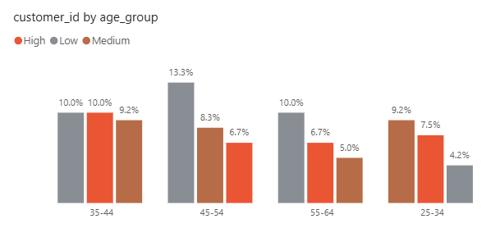
(2) Are certain customer segments (age, gender, group) more loyal than others?

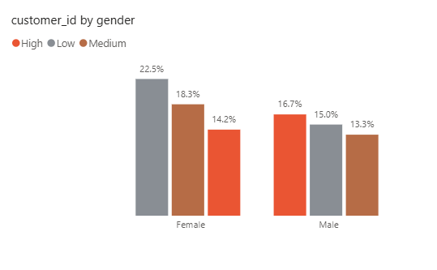
Customer share by Age_Group and Loyalty_Level

Customer share by Gender and Loyalty_Level
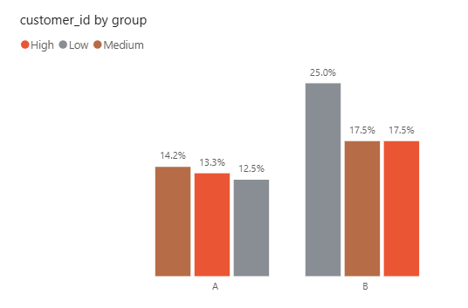
Customer share by Group and Loyalty_Level
- 35-44 has 12 High / 12 Low / 11 Medium (34.3% / 34.3% / 31.4%); 45-54 has the most Low-loyalty customers at 16 of 34 (47.1% of that group).
- By gender: Female (66 customers) — 17 High / 27 Low / 22 Medium (25.8% High, 40.9% Low); Male (54 customers) — 20 High / 18 Low / 16 Medium (37.0% High, 33.3% Low). Males are proportionally more loyal than females.
- By group: Group A (48 customers) — 16 High / 15 Low / 17 Medium (33.3% High, 31.3% Low); Group B (72 customers) — 21 High / 30 Low / 21 Medium (29.2% High, 41.7% Low). Group A has a healthier loyalty mix; Group B skews Low despite being the larger group.
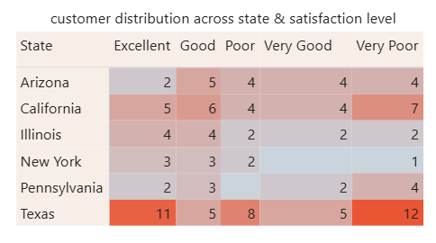
(3) Which locations report consistently high or low satisfaction scores?

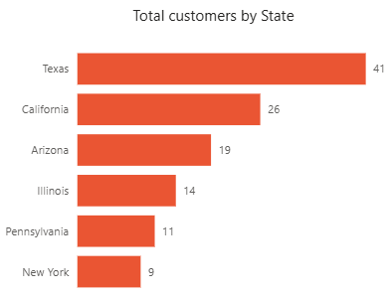
Customer distribution across State and Satisfaction_Level
Total customers by State
- Texas has both the largest customer base (41) and the widest spread of outcomes: 11 Excellent and 12 Very Poor ratings, so its mid-table average hides a genuinely divided customer base.
- California (26 customers) also shows a heavier Very Poor count (7) relative to its size.
- Illinois and New York, the smaller states, show comparatively few Poor/Very Poor responses.

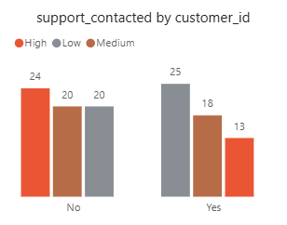
(4) Does contacting customer support negatively impact satisfaction?
Customer loyalty count by Support_Contacted
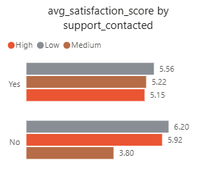
Avg. satisfaction score by Support_Contacted
- By loyalty count: customers who did not contact support (64) are 37.5% High-loyalty and 31.3% Low; customers who did (56) are 23.2% High and 44.6% Low.
- By average score, customers who did not contact support average 6.20 (High), 5.92 (Low) and 3.80 (Medium); those who did average 5.56 (High), 5.22 (Low) and 5.15 (Medium).
- Both views agree: contacting support is associated with lower loyalty and, among High- and Low-loyalty customers, a lower average score.
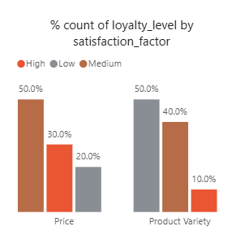
(5) How do factors like "Price" or "Product Variety" influence customer loyalty?
% count of Loyalty_Level, filtered to Price and Product Variety
- Among customers who cited Price as their satisfaction factor: 50% Medium loyalty, 30% High, 20% Low.
- Among customers who cited Product Variety: 50% Low loyalty, 40% Medium, 10% High — the weakest loyalty profile of the two factors.
- Price leans toward Medium/High loyalty, while Product Variety leans heavily toward Low loyalty. Customers who are dissatisfied with product variety are, proportionally, the least loyal group in this comparison — making it a stronger retention risk than Price.

(6) Do repeat purchasers report higher satisfaction compared to one-time buyers?
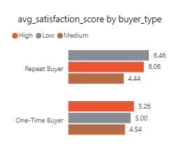
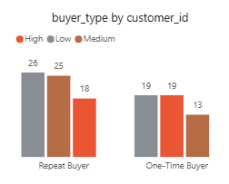
Customer loyalty count by Buyer_Type Avg. satisfaction score by Buyer_Type
- By loyalty count, Repeat (69) and One-Time (51) buyers show a broadly similar High-loyalty share, so loyalty count alone does not show repeat buyers as clearly more loyal.
- By average score, Repeat buyers score higher at every loyalty tier: 6.46 (High), 6.06 (Low), 4.44 (Medium), versus One-Time buyers at 5.26 (High), 5.00 (Low), 4.54 (Medium).
- The average-score view is the more decisive answer here: within every loyalty tier, repeat buyers are more satisfied than one-time buyers, even where their loyalty-tier mix looks similar.
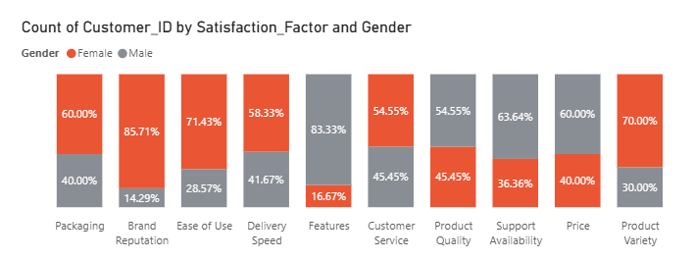
(7) Do specific demographic groups favor certain satisfaction factors?
Count of Customer_ID by Satisfaction_Factor and Gender (% within factor)
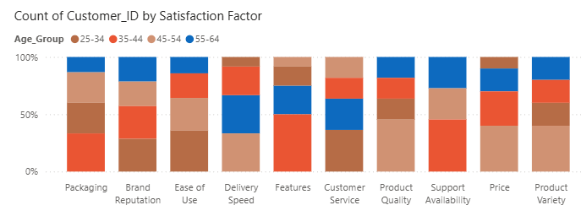
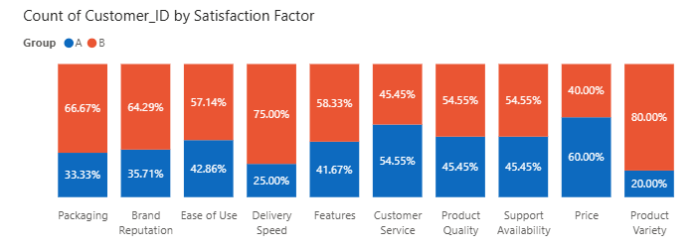
Count of Customer_ID by Satisfaction_Factor and Group (% within factor)

Count of Customer_ID by Satisfaction_Factor and Age_Group (% within factor)
- By gender: Brand Reputation (85.71% Female / 14.29% Male) and Features (83.33% Male / 16.67% Female) are the most lopsided factors; Customer Service and Product Quality are close to an even split (54.55% / 45.45%).
- By group: Product Variety skews 80% Group A / 20% Group B; Delivery Speed skews the other way, 75% Group B / 25% Group A.
- The age-group breakdown (not shown) is more even across factors than gender or group, suggesting gender and customer group are the stronger lenses for targeting messaging by factor.

(8) What is the relationship between loyalty level and satisfaction score?
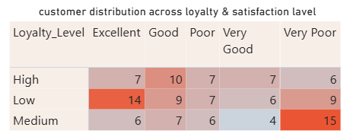
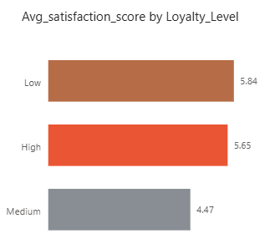
Customer distribution across Loyalty_Level and Satisfaction_Level

Avg. satisfaction score by Loyalty_Level
- Avg. satisfaction score by Loyalty_Level, confirmed against the underlying data table: Low = 5.84, High = 5.65, Medium = 4.47.
- The matrix shows a consistent picture: Low-loyalty customers have both the most Excellent ratings (14) and a large Very Poor count (9), while Medium-loyalty customers have the most Very Poor ratings (15) of any tier.
- Finding: Low-loyalty customers report the highest average satisfaction, while High-loyalty customers average lower. This means Loyalty_Level is not derived from Satisfaction_Score — it reflects a separate measure (likely purchase frequency, tenure, or spend). A customer can be satisfied with a single purchase and never return (Low loyalty, high satisfaction), while another keeps buying out of habit despite a middling experience (High loyalty, lower satisfaction).
- Implication: satisfaction and loyalty should be treated as two distinct levers at OmniRetail — raising satisfaction scores will not automatically raise loyalty, so retention strategy needs its own set of actions separate from satisfaction-driven fixes.

REPORT PAGE
The Power BI dashboard comprises three report pages:
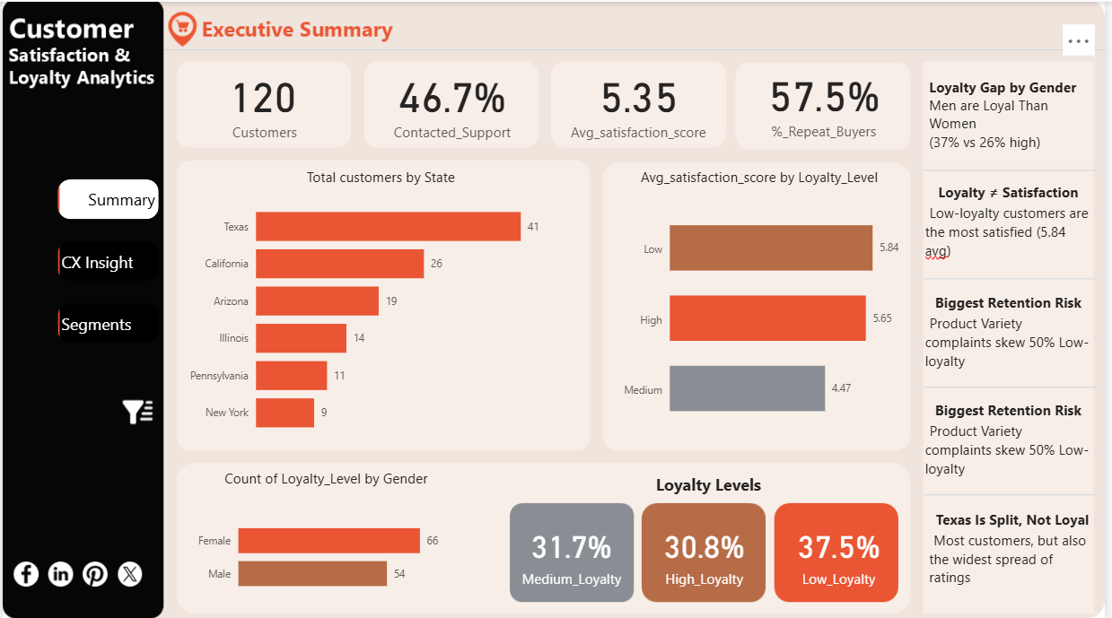
- Summary Page: a single-screen overview page

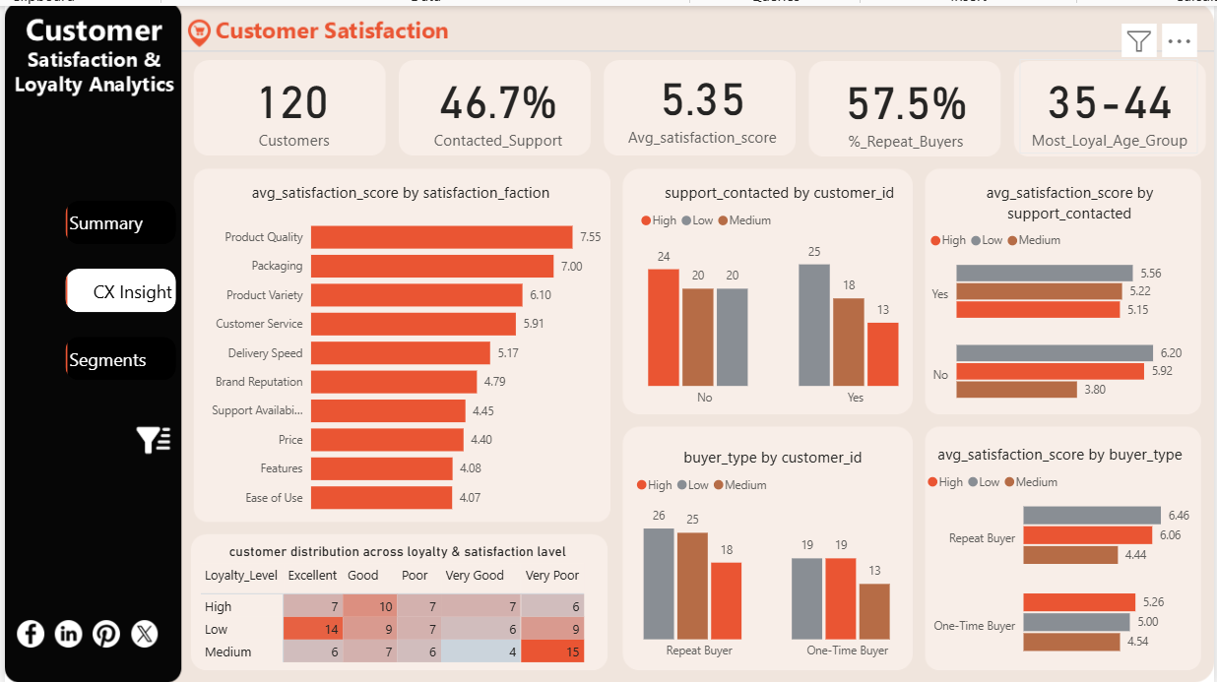
- Customer Satisfaction (Customer Experience (CX) Insight): satisfaction KPIs, average score by factor, the loyalty × satisfaction matrix, and the support-contacted and buyer-type comparisons (both as counts and as average scores).

- Loyalty, Segmentation & Preference (Segments): three tab views (Age Group / Gender / Group) showing satisfaction-factor preference and loyalty split for each segment type, plus the state-level satisfaction matrix and the Price/Product Variety loyalty view.
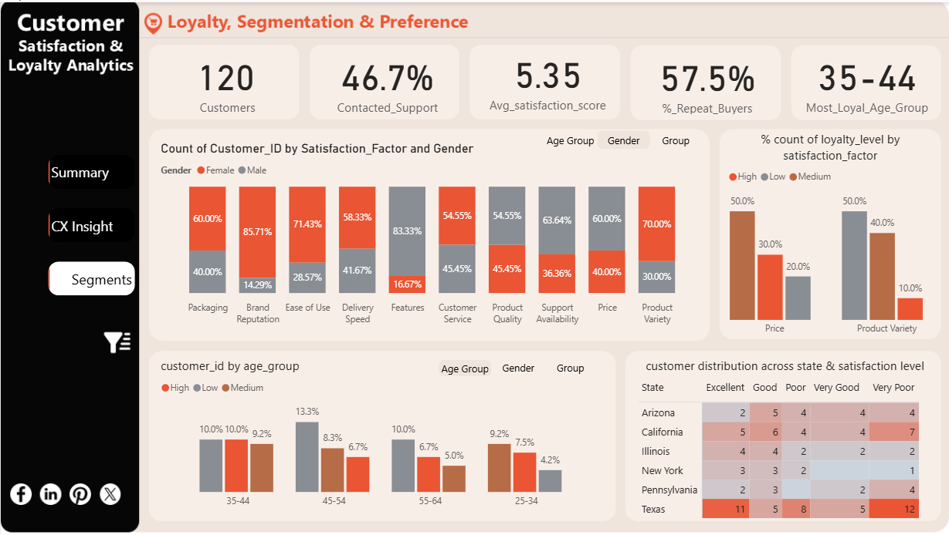

RECOMMENDATIONS
- Investigate Ease of Use and Price first: they have the lowest average satisfaction scores (4.07 and 4.40) and are cited by a meaningful share of customers, making them the most direct levers on overall satisfaction.
- Review the support experience: customers who contact support report both lower loyalty and lower average satisfaction at every loyalty tier, which points to the support interaction itself (not just the issue behind it) as worth auditing.
- Target retention by segment, not just by headline: males and Group A customers show healthier loyalty rates than the dashboard's single "35-44 | Female" and "Texas" cards suggest, so campaigns should use the within-group rates in Section 2 rather than the count-based "most loyal" cards.
- Treat Texas as two problems, not one: its large Excellent and large Very Poor counts suggest distinct causes worth separating (e.g., by city) rather than a single statewide fix.
- Use repeat-purchase status as a satisfaction lever: repeat buyers are more satisfied than one-time buyers at every loyalty tier, so onboarding or loyalty-program nudges that convert one-time buyers to repeat buyers are likely to raise satisfaction as well as revenue.

